1. Các thẻ cơ bản:

https://glitch.com/edit/#!/aspiring-storm-laugh?path=index.html%3A77%3A12

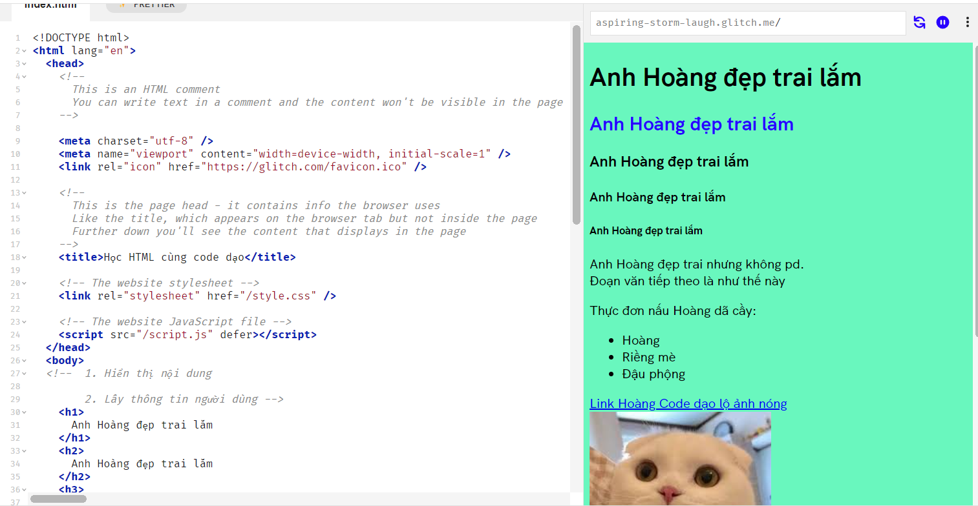

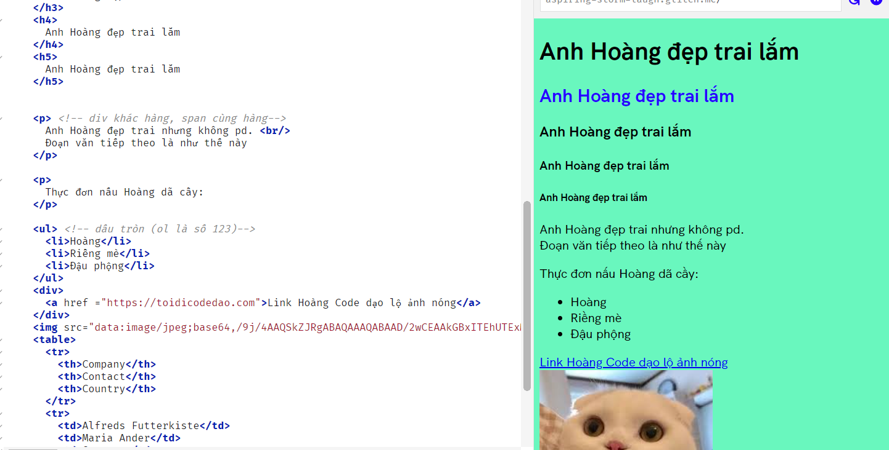

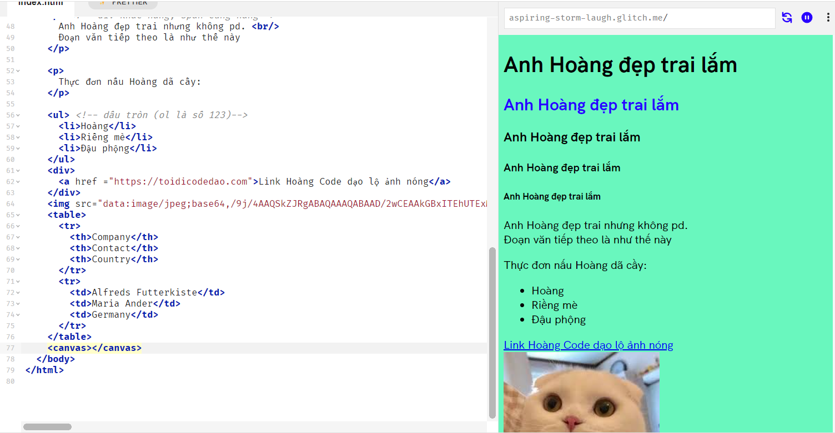

2. <https://glitch.com/edit/#!/spangled-glossy-diabloceratops?path=index.html%3A1%3A0>

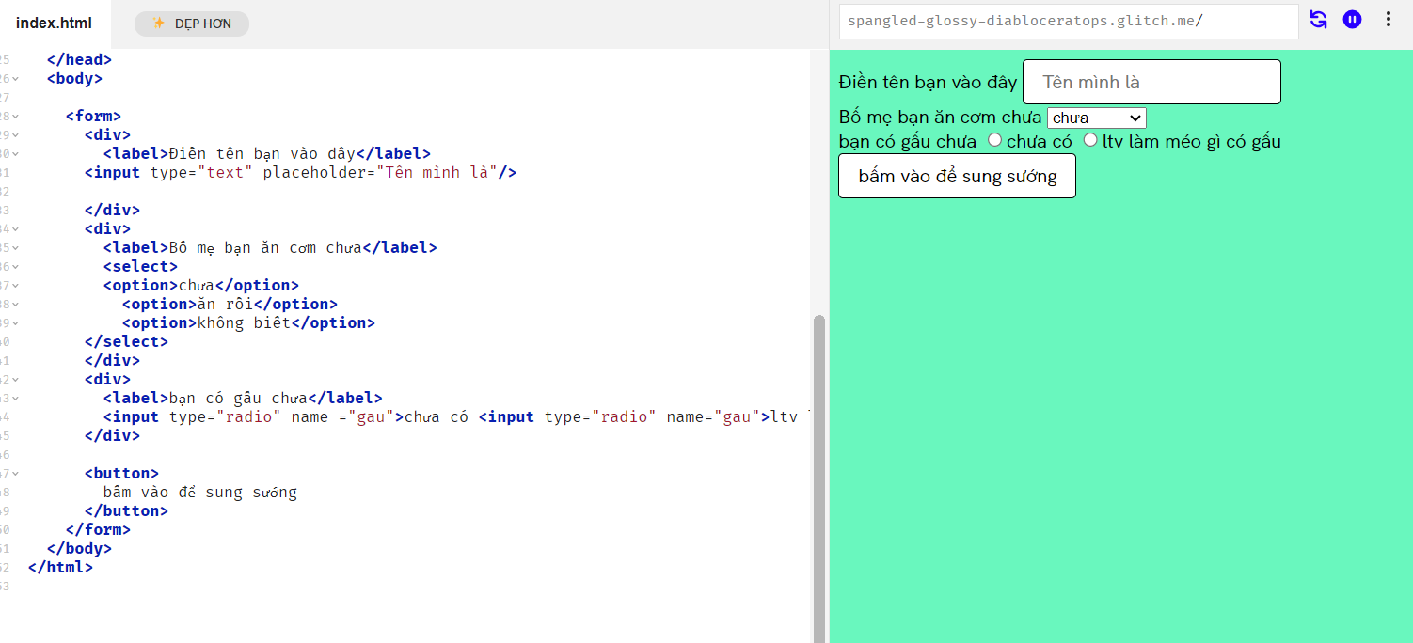

3. <https://glitch.com/edit/#!/chiseled-alluring-pyroraptor?path=index.html%3A62%3A67>